**Final Proposal**

Title: *Texturize*

*Texturize* is an interactive Mirror Maze using projection, Processing and Kinect. I want to project the video as texture on 3D objects. I intend to design multiple 3D objects that will move/zoom/transform along with viewer's movements.

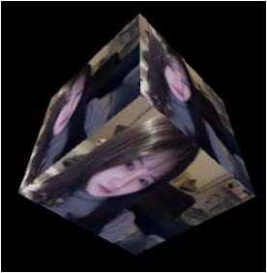

I have noticed artworks that include mirror as element are most appealing to spectators, and also to myself. The idea of mirror gave viewer a direct sense of participation. People always think that what they see in the reflection of a mirror is reality, but truth is it's not.

*Texture* is a term we normally used in 3D modeling software in order to make 3D object looks more real.

I aim to texturize the objects I make, extending concepts from my old animation work entitled “*Mirror Labyrinth*”.

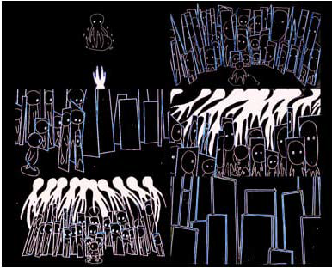

Medium: Kinect + Projection How to Exhibit:

A wall as a canvas to be projected on.

A Kinect on the wall.

A projector Installed at the cross of the canvas's wall.

What skills and techniques do I already know: Making 3D objects in processing

Add a webcam capture

Make objects interact with mouse movement. What skills and techniques do I need to research and learn: How to make more complex 3D object in processing, like 3D particle systems, etc..

How to connect the processing and Kinect (especially how to add depth and how to modify it).

Calendar: November 9-16: make 3D interactive texturized object In processing.November 16-30: learn how to make more and more complex 3D objects and assign each of them with different interactivity.

November 30-December 7: Get feedback and refine the final work.

December 7: Final Exhibition